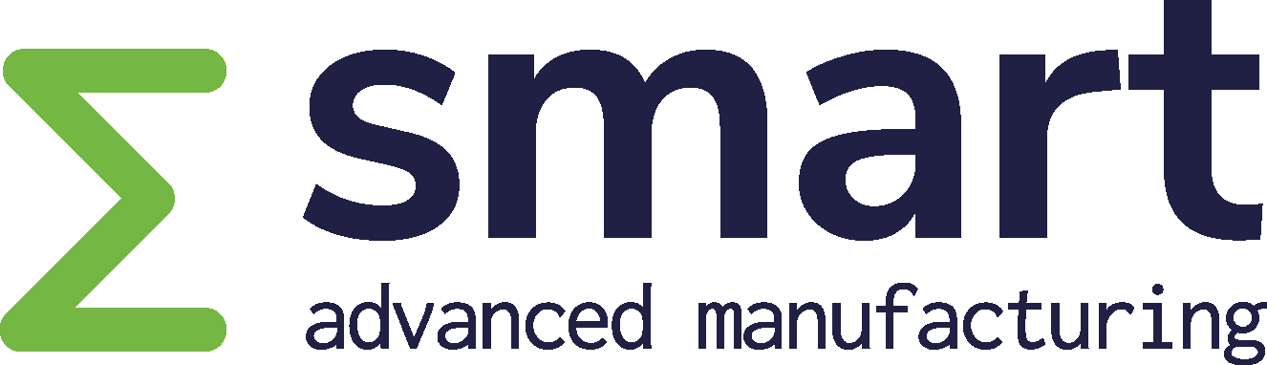
Project Outline Template
Template for SMART Project Outline submissions
TEMPLATE
September 2026
SMART Office
Gipuzkoa Science and Technology Park | Paseo Mikeletegi, 59 | 20009 Donostia - San Sebastián, Spain
info@smarteureka.com | www.smarteureka.com

Contents
1 Rationale of the project 5
1.1 One-page description 5
1.2 Problem statement and market value chain 5
1.3 Project innovations and technology value chain/solutions 5
2 Market and societal targeted impact 6
2.1 Expected impact and exploitation opportunities 6
2.2 Market analysis 6
2.3 Consortium market access 6
2.4 Partner market access 7
2.5 Contribution to SDGs (Sustainable Development Goals) 7
3 Technology 8
3.1 Summary of technological innovation and novelty in relation to the SoTA and strategic relevance 8
3.2 State of the art (SoTA) analysis 8
4 Consortium Overview 9
4.1 Consortium roles and contributions 9
4.2 Partner descriptions/profiles 9
4.3 Cooperation added value: Business level 10
4.4 Cooperation added value: Technology level 10
5 Cost information table 12
6 Rationale for SMART procedure and public funding 13

Instructions to proposers
- Replace all text in angle brackets and square brackets. Add or delete table rows as needed but keep the requested information and section sequence.
- The green guidance boxes explain the information and evidence expected in each section.
- Respect the recommended section limits. Figures, diagrams and tables count towards the relevant section limit unless the call instructions state otherwise.
- A Letter of Intent (LoI) is mandatory for every participant and must be submitted separately in accordance with the current LoI template instructions. The mandatory PO Cost Template must also be submitted as a separate Excel file, and its financial summary table must additionally be pasted into Section 5 of this narrative template.
- Express every budget figure in k€ and every human-resource figure in person-years, PY (1 PY = 12 PM).
- Ensure all partner, resource, cost and timing information is consistent across the PO, online form and cost template.
- Write clearly, coherently and in professional English.
- Keep the proposal focused and concise, avoiding unnecessary detail and repetition.
- Use figures, diagrams, tables and other visual aids where appropriate to explain complex information clearly and facilitate understanding of the proposal.

Eligibility and consistency checks
- ☐ At least two industrial companies from two different countries participating in the call.
- ☐ The project has a civil purpose and is innovative, market-oriented and related to advanced manufacturing.
- ☐ Participants from one country do not jointly account for 70% or more of the total project budget; any more restrictive national limits have been checked with the relevant NFA.
- ☐ National funding rules and eligibility conditions have been checked with the relevant National Funding Authorities.
- ☐ Partner names, countries, budgets, effort, starting date and duration are identical in all submission documents.
  - PO proposal document (PDF)
  - PO Cost template (Excel)
  - Clusters Projects Tool https://cluster-projects.eurestools.eu

Project identification and key information
Proposal full name | <Full project title>
Acronym / short name | <Acronym>
Project coordinator | <Organisation legal name / short name / country>
Planned starting date | <dd/mm/yyyy>
Duration | <00 months>
Total human resources in PY (1 PY = 12 PM) | <0.00 PY>
Total eligible cost | <0.0 k€>
Abstract (maximum 10 lines)
<Insert a concise project abstract (maximum 10 lines)>

Consortium
Participant name | Country
<Project coordinator – organisation name> | <Country>
<Project participant – organisation name> | <Country>
<Project participant – organisation name> | <Country>
<Project participant – organisation name> | <Country>
<Project participant – organisation name> | <Country>
<Project participant – organisation name> | <Country>
<Project participant – organisation name> | <Country>

SMART application sector(s) — select all applicable from the SMART Technology Roadmap
☐ Aeronautics | ☐ Automotive
☐ Consumer Goods | ☐ Capital Goods
☐ Railways | ☐ Healthcare
☐ Energy | ☐ Agro-processing
☐ Other(s): Specify

SMART research and innovation domain(s) — select all applicable from the SMART Technology Roadmap
☐ Advanced Manufacturing Processes | ☐ Intelligent and Adaptive Manufacturing Systems
☐ Design safe, sustainable and digital products | ☐ Digital, Virtual and Efficient Companies
☐ Human Manufacturing (including Person-Machine Collaboration and Human Centric Manufacturing) | ☐ Sustainable Manufacturing Towards a Circular Economy
☐ Customer-based Manufacturing | ☐ New Business Models
Consistency requirement: all figures and partner information must match the online submission form and the mandatory cost template. All budget figures must be in k€ and all human-resource figures in PY (1 PY = 12 PM).

1 Rationale of the project

1.1 One-page description
Recommended maximum length: 1 page
Applicants should:
- Provide a self-contained overview that allows the project to be understood without consulting the rest of the proposal.
- Summarise the problem and market context, the proposed innovations and solution, the expected impact and exploitation opportunities, the main technological novelty and strategic relevance, and the consortium.
- Use concrete language, focus on the essential messages and avoid unexplained technical detail; the complete narrative must fit on one page.
[Insert the proposal text here.] Delete the guidance box above before final submission

1.2 Problem statement and market value chain
Recommended maximum length: up to 2 pages
Applicants should:
- Describe the problem or unmet need, the current situation, limitations and bottlenecks, and the users, customers or stakeholders affected. Support the description with relevant evidence where appropriate.
- Describe the market value chain: the processes and actors involved in creating, integrating, delivering, using and supporting the relevant products or services, including key interfaces and dependencies.
- Show where the problem occurs in the value chain, why it is important and timely, and where the consortium is positioned. Do not describe the proposed solution in detail in this section.
[Insert the proposal text here.] Delete the guidance box above before final submission

1.3 Project innovations and technology value chain/solutions
Recommended maximum length: up to 2 pages
Applicants should:
- Explain the core project idea, the principal innovations and the project objectives, and show how they directly address the problem and market need described above.
- Describe the technology value chain or solution architecture, including the main functions, modules, building blocks, flows, interfaces and dependencies, and identify the role of the partners in the proposed solution.
- Indicate the starting point and intended maturity of the main solution elements and the expected project results. Keep the detailed comparison with the state of the art for the Technology section.
[Insert the proposal text here.] Delete the guidance box above before final submission

2 Market and societal targeted impact

2.1 Expected impact and exploitation opportunities
Recommended maximum length: up to 2 pages
Applicants should:
- Describe the expected industrial, economic, market, societal and environmental effects of the project and identify the organisations, customers, users or other stakeholders that will benefit.
- Link each expected impact to the relevant project innovation or result and quantify the expected change through credible indicators, baselines, targets or other evidence wherever possible.
- Explain the principal exploitation opportunities, intended routes to market or other forms of uptake, responsible partners and expected timing. Address intellectual property, standardisation or knowledge transfer where relevant.

[Insert the proposal text here.] Delete the guidance box above before final submission

2.2 Market analysis
Recommended maximum length: up to 2 pages
Applicants should:
- Focus on the actual markets and customer segments targeted by the project partners and explain their relevance to the proposed project.
- Provide relevant and up-to-date evidence on market size, trends, growth, geographic differences, customers, competitors, alternative solutions, barriers and potential threats. Identify the sources and dates of quantitative information.
- Explain how the market is expected to evolve, what differentiates the proposed approach and why the assumptions regarding demand and competitive positioning are credible.
[Insert the proposal text here.] Delete the guidance box above before final submission

2.3 Consortium market access
Recommended maximum length: up to 1 page
Applicants should:
- Explain the consortium-level access to target markets, customers, end users, industrial validation environments and relevant value-chain actors.
- Describe the combined route to exploitation or uptake, including the way partners will work together after project completion and the role of intellectual property, standardisation or regulatory access where relevant.
- Demonstrate why the consortium as a whole is credible and well positioned to convert successful project results into significant market or societal impact. Keep partner-specific plans in the next section.
[Insert the proposal text here.] Delete the guidance box above before final submission

2.4 Partner market access
Recommended maximum length: up to ½ page per partner
Applicants should:
- For every partner, identify the relevant project result or opportunity, target market or users, current market position or access channels, route to exploitation or impact, and expected timing.
- Provide concise evidence of the customer relationships, references, assets, networks or other capabilities that support the proposed market-access plan.
- For universities and research organisations, describe the applicable knowledge-transfer, licensing, training, standardisation or other route to impact.

[Insert the proposal text here.] Delete the guidance box above before final submission

2.5 Contribution to SDGs (Sustainable Development Goals)
Recommended maximum length: up to 1 page
Applicants should:
- Identify only the UN Sustainable Development Goals and specific targets that are materially relevant to the project.
- Explain the direct causal link between the proposed activities or results and the claimed contribution.
- Quantify the expected contribution through baselines, targets or other indicators wherever possible and provide credible evidence for the claims.

[Insert the proposal text here.] Delete the guidance box above before final submission

3 Technology

3.1 Summary of technological innovation and novelty in relation to the SoTA and strategic relevance
Recommended maximum length: up to 2 pages
Applicants should:
- Summarise the principal technological advances proposed by the project and compare them directly with the relevant state of the art described in the following section.
- Clarify what is genuinely novel, what technological challenge or breakthrough is involved, and how the proposed solution builds on or differs from existing products, prototypes, research results and related initiatives.
- Explain the strategic relevance for advanced manufacturing, the selected SMART application sectors and research and innovation domains, and the relevant European or international value chains.
[Insert the proposal text here.] Delete the guidance box above before final submission

3.2 State of the art (SoTA) analysis
Recommended maximum length: up to 2 pages
Applicants should:
- Describe the current industrial and academic state of the art relevant to the proposed solution, including current products, prototypes, research results, standards and technological trends where applicable.
- Use relevant and up-to-date sources and explain how related EUREKA, EU and other projects, including the partners’ previous or ongoing work, relate to the proposal.
- Identify the limitations, gaps or unresolved challenges that the project will address. Avoid repeating the market analysis and keep the discussion focused on the technological baseline.
[Insert the proposal text here.] Delete the guidance box above before final submission

4 Consortium Overview

4.1 Consortium roles and contributions
Recommended maximum length: up to 2 pages
Applicants should:
- Define each partner’s role, responsibilities, principal activities and specific contribution to the proposed innovations, solution and expected results.
- Demonstrate complementarity and balance across the consortium, including the relevance of each partner’s expertise, assets, market position and intended exploitation role.
- Explain the main interfaces and dependencies between partners and countries and avoid inactive, weakly justified or duplicative participation.

Partner | Country | Type¹ | Main role² | WPs / tasks | Key contribution
[Short name] | [Country] | [Type] | [Role] | [IDs] | [Contribution]
[Short name] | [Country] | [Type] | [Role] | [IDs] | [Contribution]
[Short name] | [Country] | [Type] | [Role] | [IDs] | [Contribution]
[Short name] | [Country] | [Type] | [Role] | [IDs] | [Contribution]
[Short name] | [Country] | [Type] | [Role] | [IDs] | [Contribution]
[Short name] | [Country] | [Type] | [Role] | [IDs] | [Contribution]
[Short name] | [Country] | [Type] | [Role] | [IDs] | [Contribution]
[Short name] | [Country] | [Type] | [Role] | [IDs] | [Contribution]
¹ Type: I = Industry / Large Company; S = SME (Small and Medium-sized Enterprise); U = University; R = Research Institute.
² Main role: C = Coordinator; P = Partner; SC = Subcontractor.
[Insert the proposal text here.] Delete the guidance box above before final submission

4.2 Partner descriptions/profiles
Recommended maximum length: up to ½ page per partner
Applicants should:
- Provide a concise profile for every partner, focusing on project-relevant capabilities and strengths.
- Describe core business or mission, relevant products or research, expertise, infrastructure, track record, key personnel and capacity to perform the proposed role.
- Explain the capacity to exploit, transfer or use the expected results. Avoid generic corporate descriptions that do not support the proposed participation.

<PARTNER SHORT NAME> — <LEGAL NAME> (<COUNTRY>; <ORGANISATION TYPE>)
[Insert a concise narrative covering the partner’s project-relevant capabilities, track record, assets, key personnel, assigned role and capacity to exploit, transfer or otherwise use the expected results.]
[Repeat this box for every partner.]

4.3 Cooperation added value: Business level
Recommended maximum length: up to 1 page
Applicants should:
- Explain the business rationale for the consortium and what the partners can achieve together that they could not achieve independently.
- Assess the completeness of the market value chain, end-user or customer involvement, the business benefits for the partners and participating countries, and the added value of the international cooperation.
- Identify any business gaps, overlaps or missing value-chain links and explain why they do not undermine the project or how they will be managed.
[Insert the proposal text here.] Delete the guidance box above before final submission

4.4 Cooperation added value: Technology level
Recommended maximum length: up to 1 page
Applicants should:
- Explain the technological complementarity of the partners, their unique capabilities and the added value created through collaboration, integration and knowledge exchange.
- Demonstrate why the proposed international cooperation is needed to develop and validate the technological solution and why the consortium contains the necessary R&D and industrial competence.
- Identify any technical gaps, redundancies or critical dependencies and explain how they are addressed.
[Insert the proposal text here.] Delete the guidance box above before final submission

5 Cost information table
Applicants should:
• Complete the separate PO Cost Template (Excel) using the provided workbook.
• Paste an image/screenshot of the financial summary table from the completed PO Cost Template into this section so evaluators can see the same figures in the proposal.
• Submit the completed PO Cost Template as a separate Excel file together with the PO through the Cluster Projects Tool.
• Use k€ for costs and person-years (PY) for personnel effort (1 PY = 12 person-months (PM)). The PO, Excel workbook and Cluster Projects Tool must contain identical partner, effort and cost information.
• Use the Excel template as the source of the figures; do not manually recreate or alter calculated values.
[Replace the example below with an image/screenshot of the completed financial summary table from the PO Cost Template before final submission.]
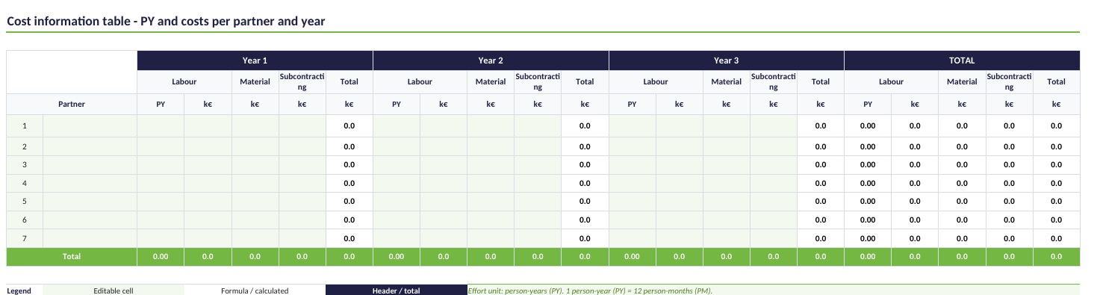

6 Rationale for SMART procedure and public funding
Recommended maximum length: up to ½ page
Applicants should:
• Explain the rationale for using the SMART procedure and for public funding, covering the following points where relevant:
• National gain: benefits for the participating countries, contribution to national strategies, competitiveness, standardisation, knowledge dissemination, productivity, wellbeing or other relevant national effects, and the benefit of international collaboration.
• Return on investment (RoI): how the investment by companies and Public Authorities is expected to generate value, revenues, jobs, productivity, industrial activity or economic growth.
• Value creation of the national sub-consortium: how cooperation and cross-fertilisation between national participants create additional value.
• Balance of the national participation: explain the contribution and effort balance between companies, SMEs, research organisations and other participants where relevant.
• NFA contact: confirm that project partners have contacted the relevant National Funding Authorities to check national eligibility and funding conditions.
[Insert the proposal text here.] Delete the guidance box above before final submission

